 |  | 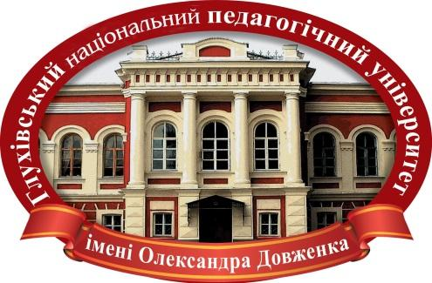
 | 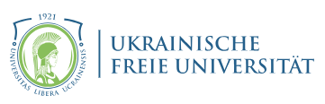 | 
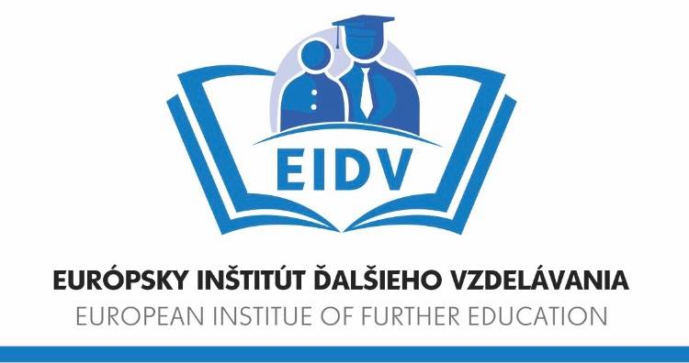 |  | 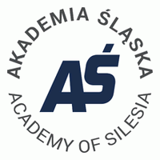

MINISTRY OF EDUCATION AND SCIENCE OF UKRAINE
OLEKSANDR DOVZHENKO HLUKHIV NATIONAL PEDAGOGICAL UNIVERSITY (UKRAINE) NATIONAL ACADEMY OF EDUCATIONAL SCIENCES OF UKRAINE
INSTITUTE OF VOCATIONAL EDUCATION AND TRAINING OF NAES OF UKRAINE
DEPARTMENT OF PROFESSIONAL EDUCATION AND EDUCATION OF ADULTS
EUROPEAN INSTITUTE OF FURTHER EDUCATION (SLOVAK REPUBLIC)
UKRAINIAN FREE UNIVERSITY (GERMANY)
POMERANIAN UNIVERSITY (POLAND)
ACADEMY OF SILESIA (POLAND)
UNIVERSITY OF MOSTAR (БОСНІЯ І ГЕРЦЕГОВИНА)

Dear colleagues!
We invite you to take part in

The V International Scientific Conference
«TECHNICAL AND VOCATIONAL EDUCATION: CHALLENGES AND OPPORTUNITIES»

The conference will be held on May 14, 2026 at the Oleksandr Dovzhenko Hlukhiv National Pedagogical University in a remote-correspondence form.

Researchers, academic and teaching staff, educators, doctoral students, postgraduate students, and higher education students are invited to participate in the conference.

TOPICS OF THE CONFERENCE:

1. Modern innovative approaches to the development of technological and vocational education in the context of European integration.
2. Scientific and methodological foundations for modernizing the content, tools, and teaching technologies in the field of technological and vocational education.
3. Implementation of the conceptual principles of specialized general secondary education.
4. Ensuring the quality of vocational education in view of the challenges of post-war economic recovery and development.
5. Formation of entrepreneurial competence and career development of future specialists to enhance their competitiveness in the modern labor market.
6. Digitalization of the educational process: digital tools, platforms, and AI for technological and vocational training.

Official languages of the conference: Ukrainian, English.
Form of participation: remote-correspondence.

Based on the results of the conference, free publication of participants’ scientific papers is planned in the electronic proceedings of the conference.
We kindly ask you to check scientific papers for the percentage of similarity using the software available to you and to submit a screenshot of the verification results indicating the software used.
To participate in the conference, it is necessary to complete the application form by May 9, 2026, using the following link:  https://docs.google.com/forms/d/e/1FAIpQLSfApuVCZgnWwg-PF3lHiAiEcKWoHoCe030t9I_IdY1P7lWYvg/viewform?usp=header  or by scanning the QR code. | 

Conference participants should submit their materials by email to the Organizing Committee at kaftpo@gmail.com, indicating «TPO conference 2026» in the subject line:
– conference paper abstracts (2–5 pages) prepared in accordance with the specified requirements (see below);
– a screenshot of the results of the similarity check of the abstracts, indicating the software used;
– peer review of the abstracts (for students, if required).

The names of the submitted files must correspond to the surname of the first author of the presentation, for example: «Shevchenko_Application», «Shevchenko_Abstracts».
Students can participate in the conference if co-authored with a teacher or with the review of a Candidate or Doctor of Sciences.
The Editorial Board carries out an independent (blind) review of the submitted materials and performs additional peer review. No discussion regarding the reasons for rejection is conducted.
The authors bear full responsibility for submitting papers that have been previously published or accepted for publication by other editions.
The electronic proceedings of the conference are planned to be published after the event. An electronic copy (PDF format) will be sent to the conference participants by email.

Each participant will receive an electronic certificate. It certifies the participation in the event or the publication of theses, and recommends the enrollment of 0.2 ECTS credit (6 hours) or 0.3 ECTS credit (9 hours), respectively.

Requirements for abstracts
Texts prepared only in Microsoft Word format are accepted for editing

Sheet format | A4
Fields | top and bottom - 2 cm, left - 3 cm, right - 1.5 cm
Basic font | Times New Roman
Font size of the main text | 14 point
Line spacing | one and a half
Text alignment | by page width
Paragraph indent (new line) | 1 cm
Page numbering | not
Pictures | incorporated into the text
References | in square brackets [1, p. 2], list of references at the end

The list of used literature sources is given at the end of the text in alphabetical order under the name «References» one line after the main text. References should be written according to the APA (American Psychological Association) style.
In case the submitted materials do not comply with the stated requirements, the Organizing Committee reserves the right not to include them in the conference proceedings without additional revision by the authors.

You can submit an article for publication of articles in a scientific printed journal «BULLETIN OF OLEKSANDR DOVZHENKO HLUKHIV NATIONAL PEDAGOGICAL UNIVERSITY. PEDAGOGICAL SCIENCES», which is included in the List of scholarly professional editions of Ukraine of «B» category (Decree of the Ministry of Education and Science of Ukraine № 1471 of the 26th of November 2020) at the expense of the authors.
Information about the publication of the article in the scientific collection «BULLETIN of Oleksandr Dovzhenko Hlukhiv National Pedagogical University» is available at: https://journals.gnpu.edu.ua/index.php/vgnpu. In case of significant differences in the design of articles with recommendations, the editors of the collection have the right to reject the publication.
The printing of a scientific article is paid accordingly after passing the examination and recommendation for printing.

Address of the organizing committee: Kyivo-Moscowska Str., 24, Hlukhiv, Sumy Region, 41400.

Phone numbers of the organizing committee:
Associate Professor at the Department Nadiia Borysenko 066-559-04-48
Senior teacher at the Department Olha Vasylenko 095-023-28-08
Senior Laboratory Assistant Iryna Lisnevska 066-357-30-59

SAMPLE OF DESIGN ABSTRACT

Ivan SHEVCHENKO,
Candidate of Pedagogical Sciences, Associate Professor, Doctoral Student
National Pedagogical Dragomanov University
(Kyiv, Ukraine)

ABSTRACT NAME

Text. Text. [2, с. 33].

References
- Lorge, P. A. (2012). Chinese martial arts: From antiquity to the twenty-first century. Cambridge University Press.

Thank you for cooperation!

